**Logging**

**Introduction**

Logging is important, because it offers developers with data and statistics for what features are being used, and helps find and prioritize the most common errors so that developers are able to assess a hierarchy of errors to fix.

**Phases**

**Phase 1**: Create the necessary database for logging every Login/Logout attempt, forum posts, reviews, ratings, errors and all other user actions that will be determined by the front end design. Then creating tables based on the category of user action.

**Phase 2**: Link front end user action interfaces to back end databases that were created in phase 1.

**Phase 3**: Testing

**Resources**

* Research will be necessary for database creation and code writing in order to know how to build proper tables for each form of user activity, this research is estimated to take around 20 hours.
* Writing the code necessary for linking the front and back end of the web app, as well as automatic logging will be estimated to take around another 20 hours.
* Testing: 20 hours
* Total resources for logging implementation will take an estimated time of ~60 hours.

**Who is responsible?**

Saturday solution is responsible for delivering a product that will have all the proper components of logging user activity. Specific members TBD

**Risk assessment**

* Forgetfulness of logging specific data or errors which will result in an inaccurate aggregation of user data, or errors that may not be detectable thus leading to a lack of accurate assessment of user data or errors.
  + This can be prevented by running elaborate tests to ensure foreseeable risks are avoided. If there is an unforeseen risk, it will be mitigated by immediately addressing and fixing the issue.

**Interdependencies**

The Logging feature will be dependent on the UI feature and will be a dependency on the archiving feature of our application.

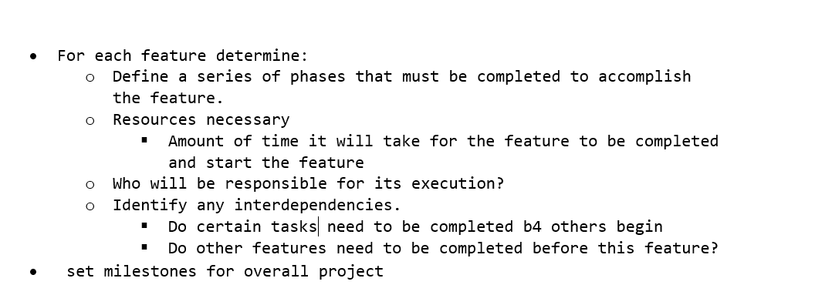The

* Create the necessary databases for each logging activity by section.
* Find the links front end actions (login,logout,user activity such as clicks) to the back end database
* Create a subroutine code to link and automate logging to a database.

Understand the implementation and its steps, resources necessary, and the road map.

Figure a new and accurate estimate and provide it.

Make sure to answer “Why” you are doing things. This documentation is for people that come along later to look at it, or ourselves, but they will want to know why we do what we do.

Part 1: Start and end of each feature.

Part 2: Determine the approach, address potential risks, and any kind of mitigation strategies the team will have in the event risks occur.

* phases of a project
* activities or tasks in each phase
* task start and end dates
* interdependencies between tasks
* Milestones

Singleton Logger static method to log all user actions by specifying the action type and parameter, ie logging in. Databases

Link front end to database table

Write code subroutine to handle automatic logging of data. Will take user input and add it to a database of logs for user actions, tables can also be split up into different tables. For example, login, logout, clicks, etc.